Name: Omkar Joshi
Roll no:- T511042
Div:- TE(A)

Practical No :-2
Creating An S3 Bucket In AWS.

Step 1 :-
- Sign in to the AWS Management Console and open the Amazon S3 console.
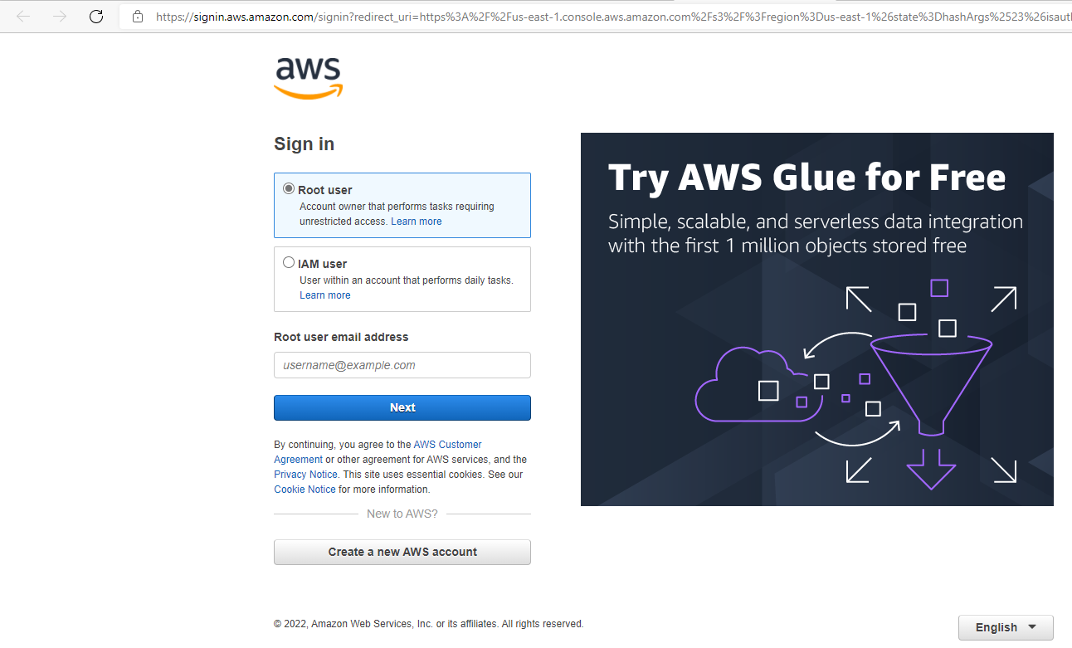
Step 2 :-
- Choose Create bucket.
- The Create bucket wizard opens.

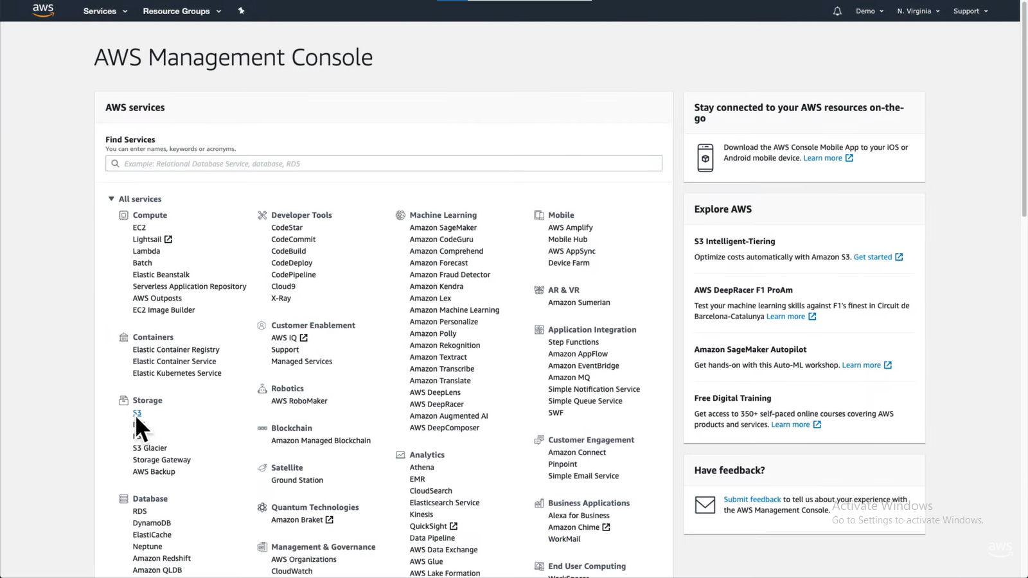
Step 3 :-
- In Bucket name, enter a DNS-compliant name for your bucket.
- The bucket name must:
  - Be unique across all of Amazon S3.
  - Be between 3 and 63 characters long.
  - Not contain uppercase characters.
  - Start with a lowercase letter or number.
- After you create the bucket, you cannot change its name.

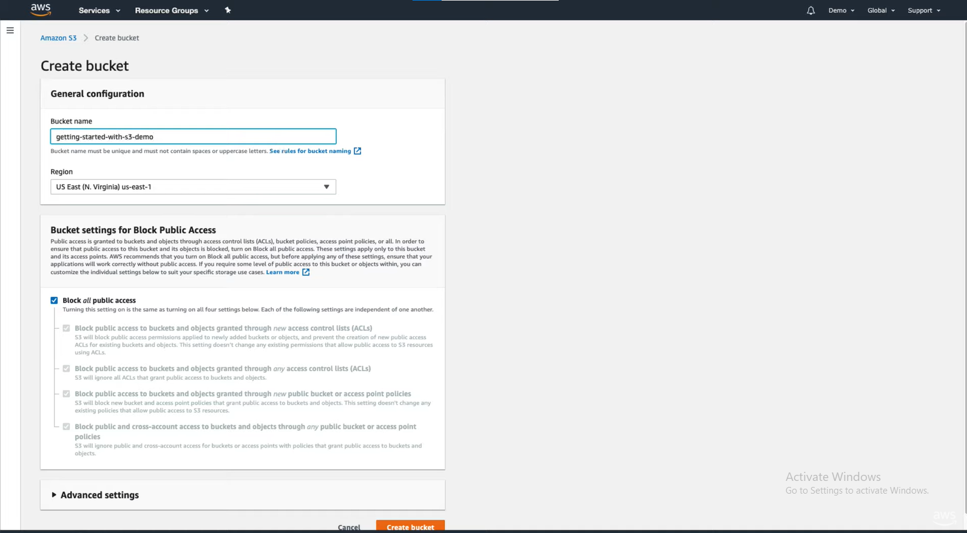

Step 4 :-
In Region, choose the AWS Region where you want the bucket to reside.
- Choose a Region close to you to minimize latency and costs and address regulatory requirements.
- Objects stored in a Region never leave that Region unless you explicitly transfer them to another Region. For a list of Amazon S3 AWS Regions.

Step 5 :-
- In Bucket settings for Block Public Access, choose the Block Public Access settings that you want to apply to the bucket.
- We recommend that you keep all settings enabled unless you know that you need to turn off one or more of them for your use case, such as to host a public website.
- Block Public Access settings that you enable for the bucket are also enabled for all access points that you create on the bucket.

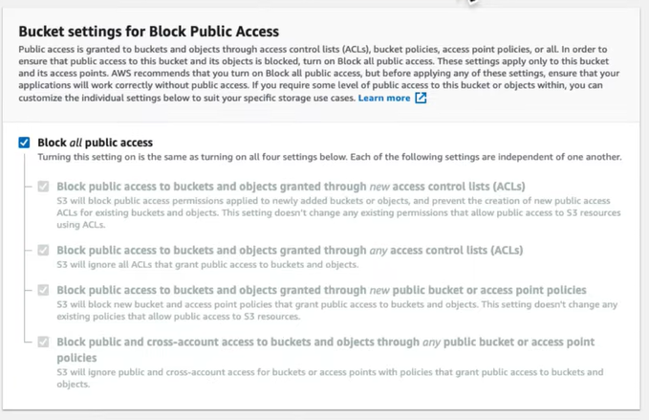
Step 6 :-
- If you want to enable S3 Object Lock, do the following:
- Choose Advanced settings, and read the message that appears.
- You can only enable S3 Object Lock for a bucket when you create it.
- If you enable Object Lock for the bucket, you cannot disable it later.
- If you want to enable Object Lock, enter enable in the text box and choose Confirm.
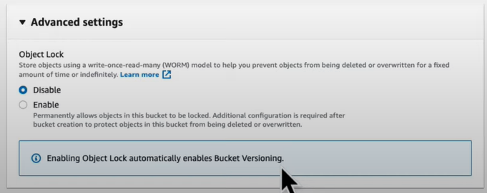
Step 7 :-
- Choose Create bucket.



